1. **Explain Merge Queries with an example?**

**Merging** is another powerful transformation to optimize our tables and information that we might be getting from various sources. Learning how to merge queries in Power BI is relevant as this transformation can simplify our data models.

Getting data from different sources in Power BI isn’t a big issue. It doesn’t really matter where the data comes from since they will just become a query. What really matters is how we structure those tables in our model.

With that said, merging is a great technique to create tables that are totally different to what we ordinarily have since we can combine a lot of tables. In this article you will learn how to merge queries in Power BI effectively.

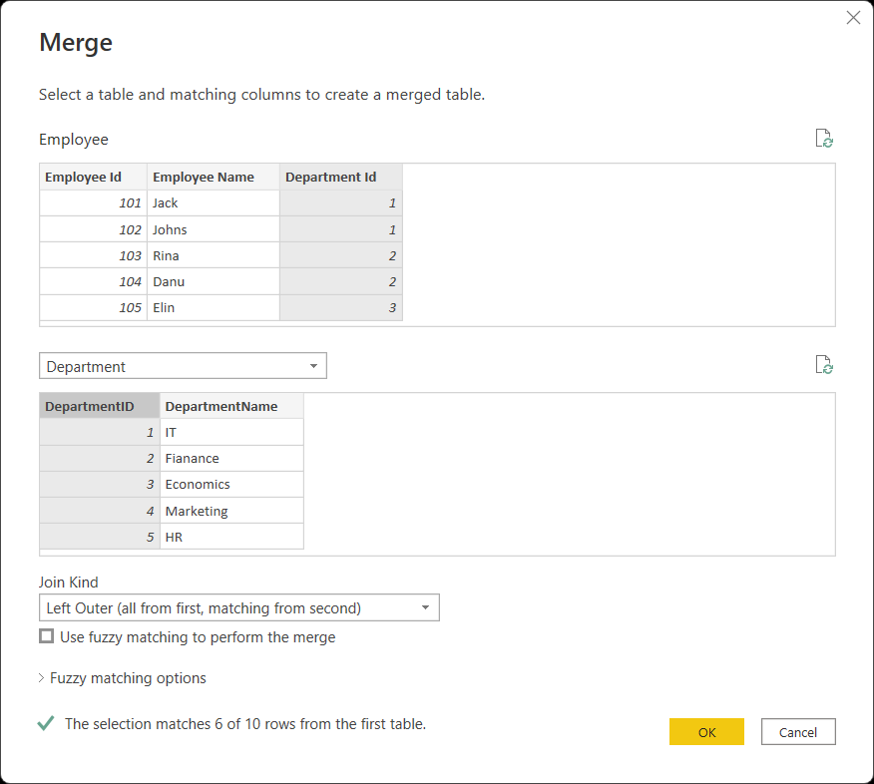

**Merge Queries Option In Power BI**

We can merge queries by using two option’s like merge queries (This will merge queries with the same data) And merge queries as new (In this it will create new queries)

**We have 5 options of joining :**

**Left outer join** : One of the join kinds available in the Merge dialog box in Power Query is a left outer join, which keeps all the rows from the left table and brings in any matching rows from the right table

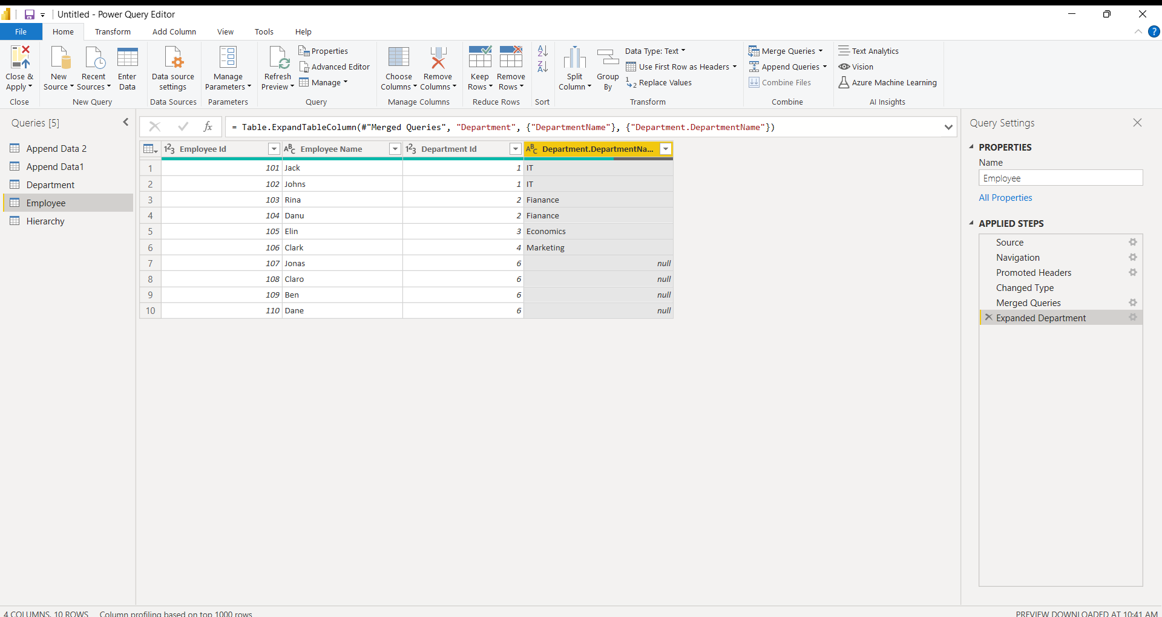

**Right outer join :** A right outer join is a method of combining tables. The result includes unmatched rows from only the table that is specified after the RIGHT OUTER JOIN clause. If you are joining two tables and want the result set to include unmatched rows from only one table, use a LEFT OUTER JOIN clause or a RIGHT OUTER JOIN clause.

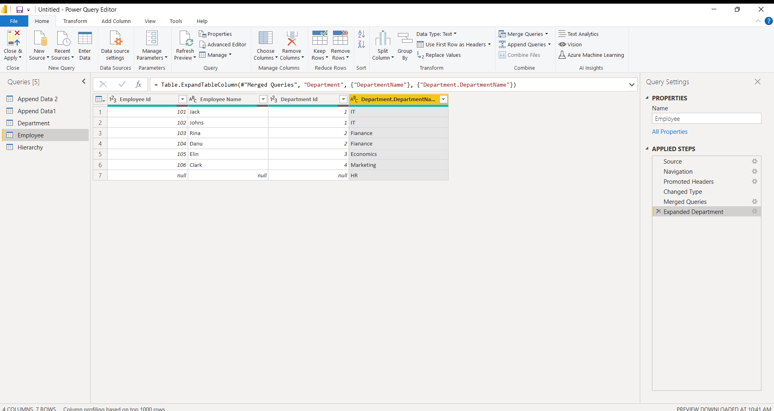

**Full outer join :** One of the join kinds available in the Merge dialog box in Power Query is a full outer join, which brings in all the rows from both the left and right tables.

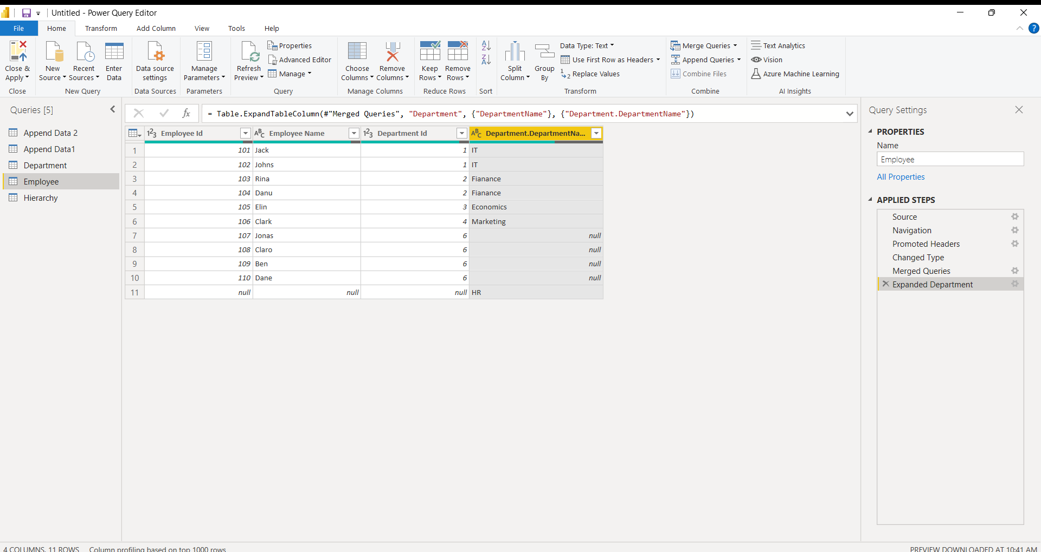

**Inner join :** An INNER JOIN is such type of join that returns all rows from both the participating tables where the key record of one table is equal to the key records of another table. This type of join required a comparison operator to match rows from the participating tables based on a common field or column of both the tables.

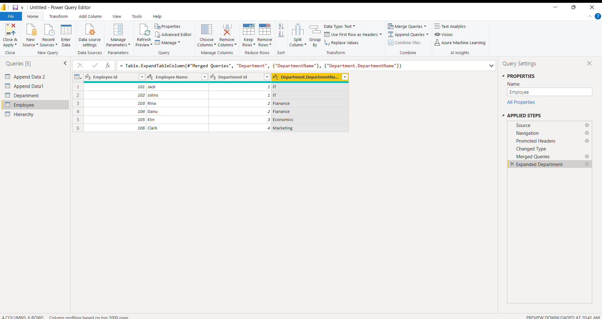

**Left anti join :** One of the join kinds available in the Merge dialog box in Power Query is a left anti join, which brings in only rows from the left table that don't have any matching rows from the right table.

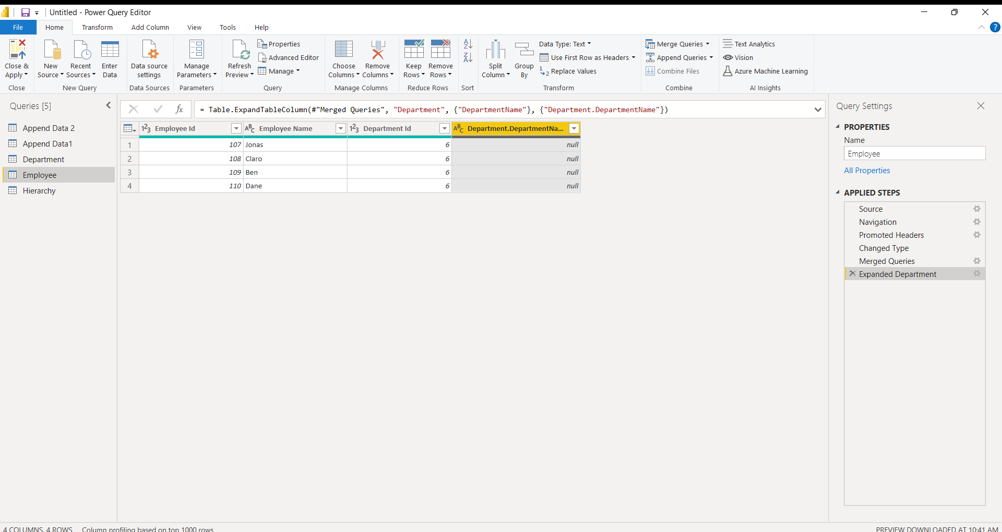

**Right anti join :** The join will be made between the following columns. The goal is to create a table like the following, where only the rows from the right table that don't match any from the left table are kept. As a common use case, you can find all the rows that are available in the right table but aren't found in the left table.

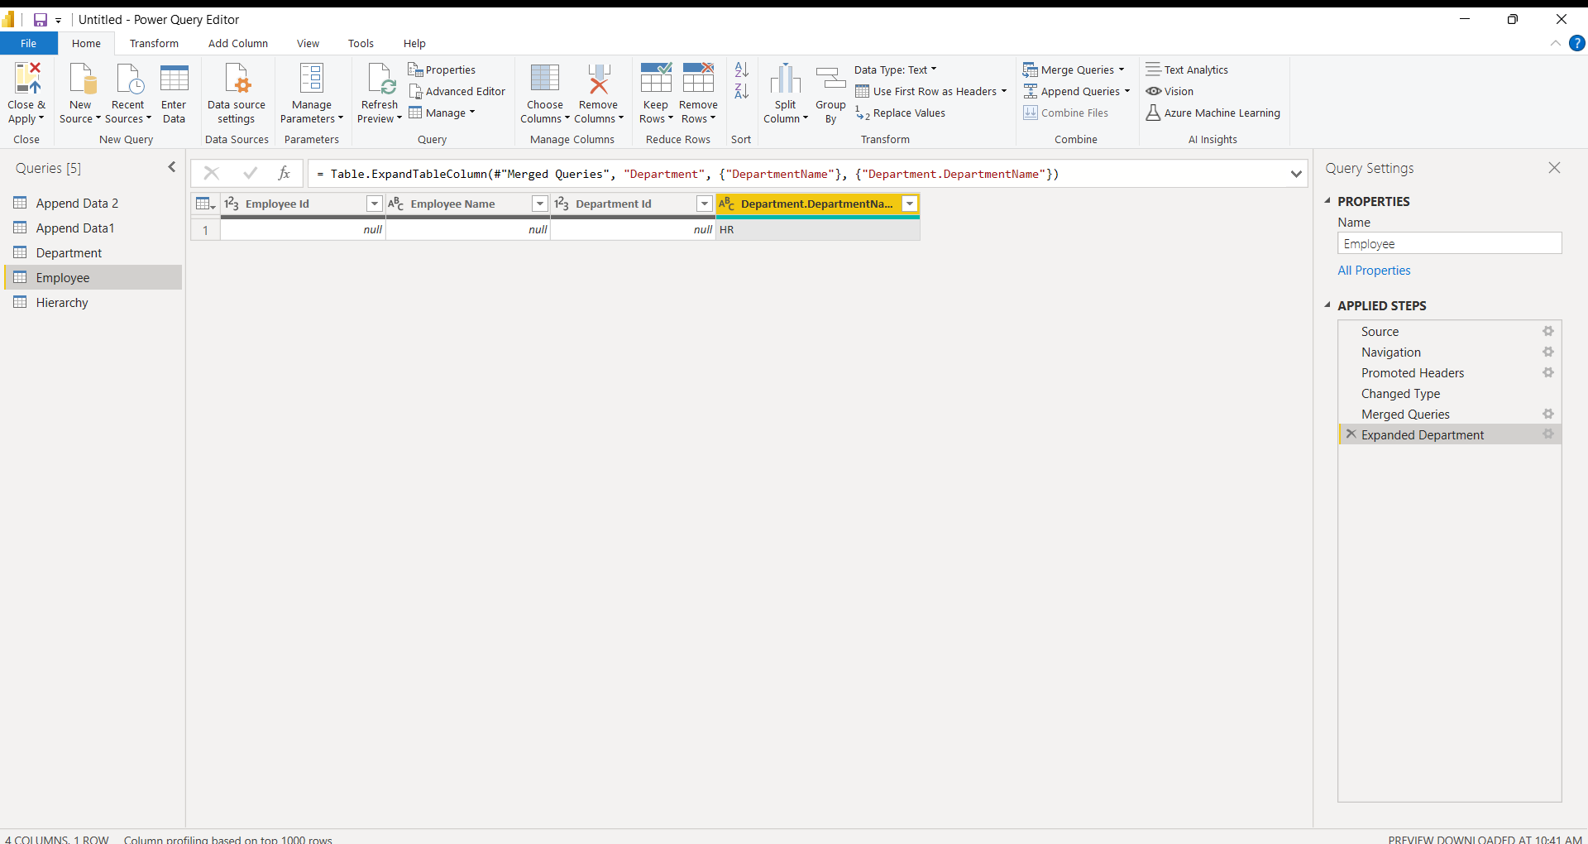

1. **Explain Append Queries with an example?**

An append operation creates a new query that contains all rows from a first query followed by all rows from a second query. The append operation requires at least two queries. These queries can also be based on different external data sources.

1. To open a query, locate one previously loaded from the Power Query Editor, select a cell in the data, and then select **Query**> **Edit**. For more information see [Create, load, or edit a query in Excel](https://support.microsoft.com/en-us/office/create-load-or-edit-a-query-in-excel-power-query-ca69e0f0-3db1-4493-900c-6279bef08df4).
2. Select **Home**> **Append Queries**. The default action is to do an inline append. To do an intermediate append, select the arrow next to the command, and then select **Append Queries as New**.  
     
   The **Append** dialog box appears.

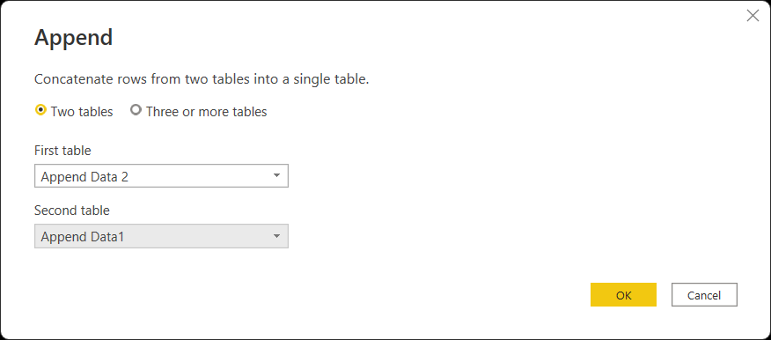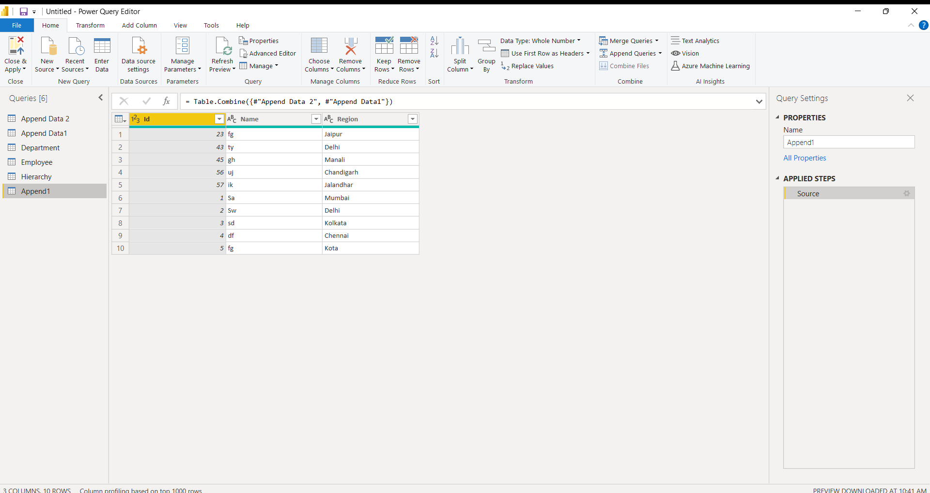

Decide the number of tables you want to append:

1. Select Two tables, and then select the second table in the drop down list box to append.
2. Select Three or more tables. From the Available tables box, add the tables you want to append to the Tables to append. Use the arrows on the right of that box to change sequence.
3. Select OK.
4. If you chose to do an inline append in step 2, a new step in the current query is created. You can continue adding steps to the same query to append additional queries.

If you chose to do an intermediate append in step 2, a new query is created. You can continue creating additional queries.

1. **Explain how to load multiple files from a folder?**
   1. Select “Get data” from the top toolbar.
   2. Under the options, select “Folder” and click “Connect”.

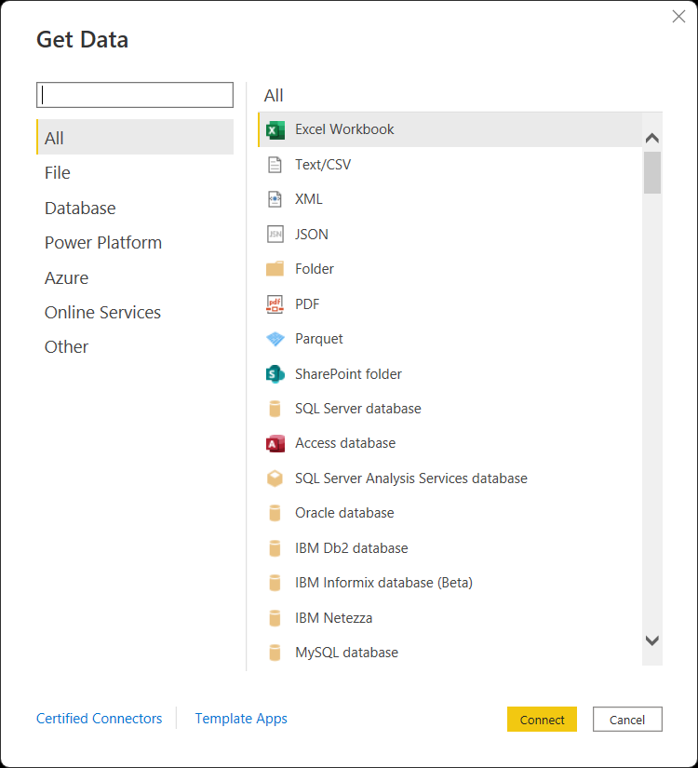

* 1. Enter the path of the folder where you have saved your files.
  2. Your files will show up and give you three options.

Load Data,

Transform Data

Combine Data – this option is new for this type of file upload.

* 1. Click on “Combine”, and two options will appear:

Combine & Transform Data

Combine & Load.

If your folder contains only the files you want and nothing else, you can go ahead and select Combine & Load.

If you need to filter out files or do any other transformation, you need to select Combine & Transform. In this example, we will be selecting Combine & Transform Data

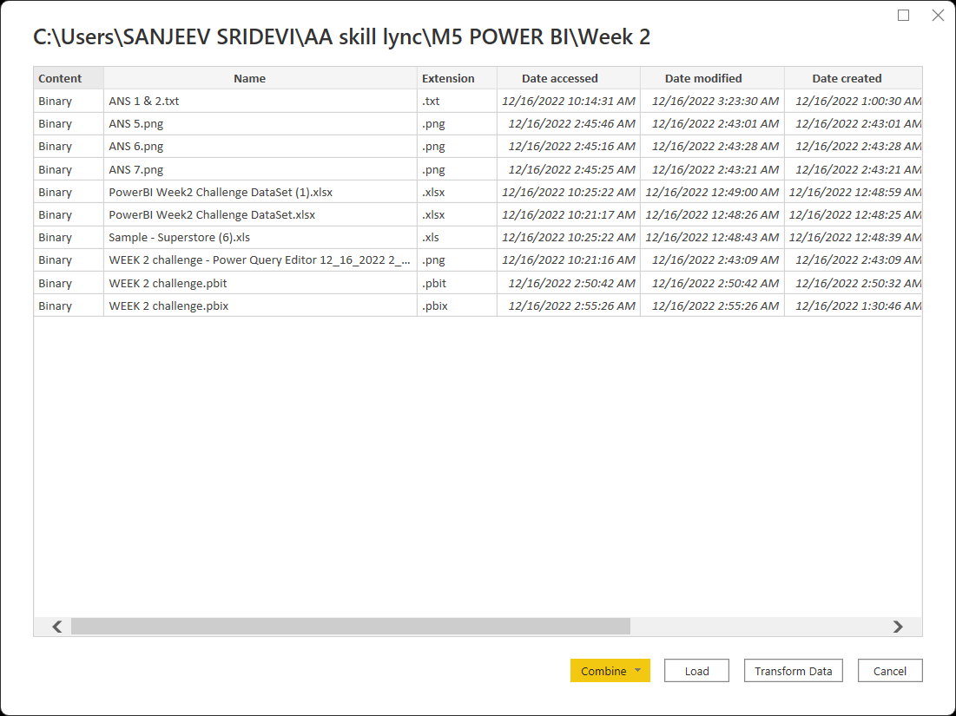

* 1. A pop-up will ask you to review the combined files.

It will show you sample data and ask you to give it the specifications for each file, for example, the delimiter type.

You will just select “OK” at the bottom in most cases.

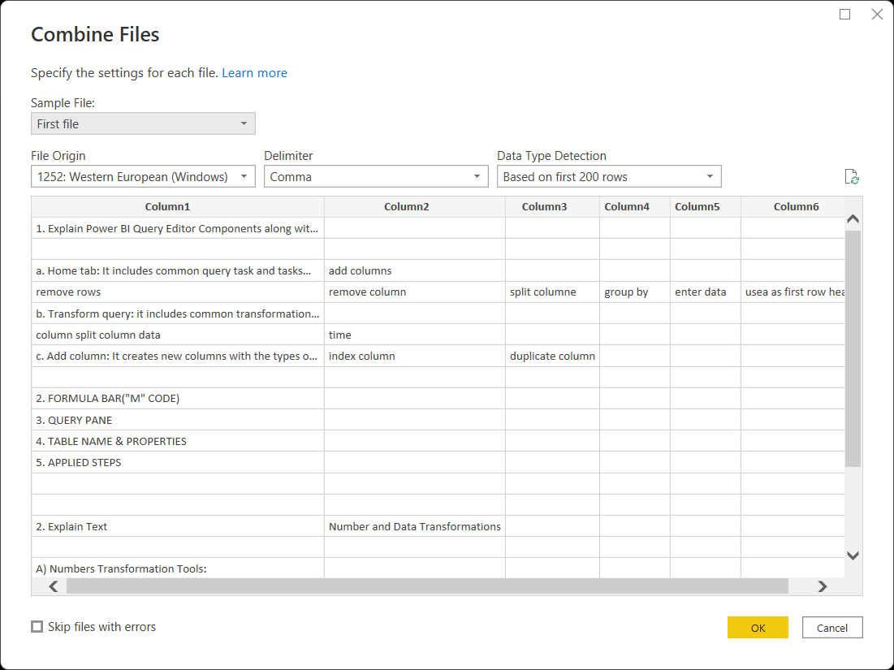

1. **Create Product Hierarchy in Power BI Desktop**

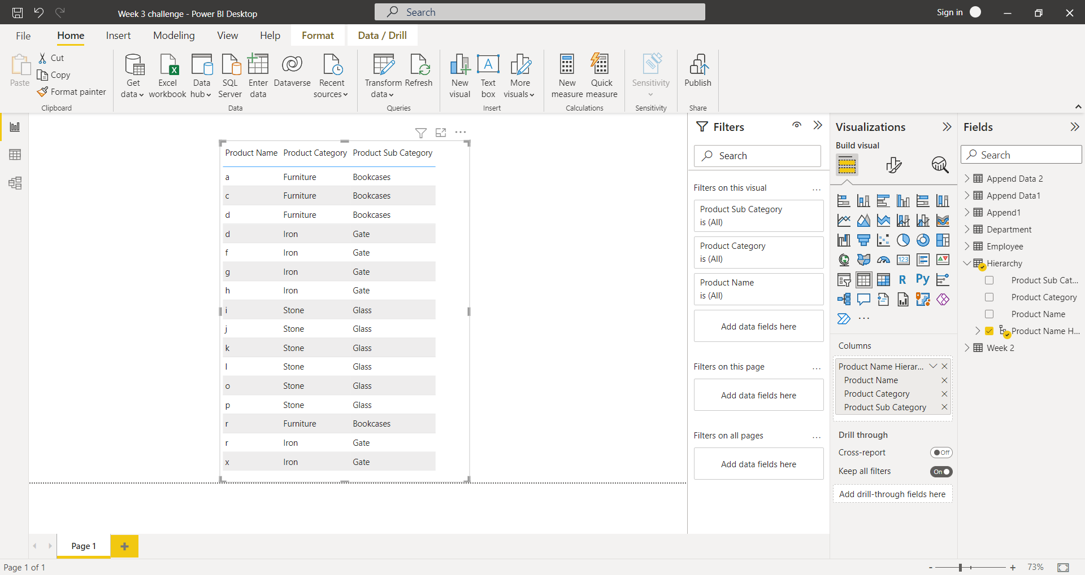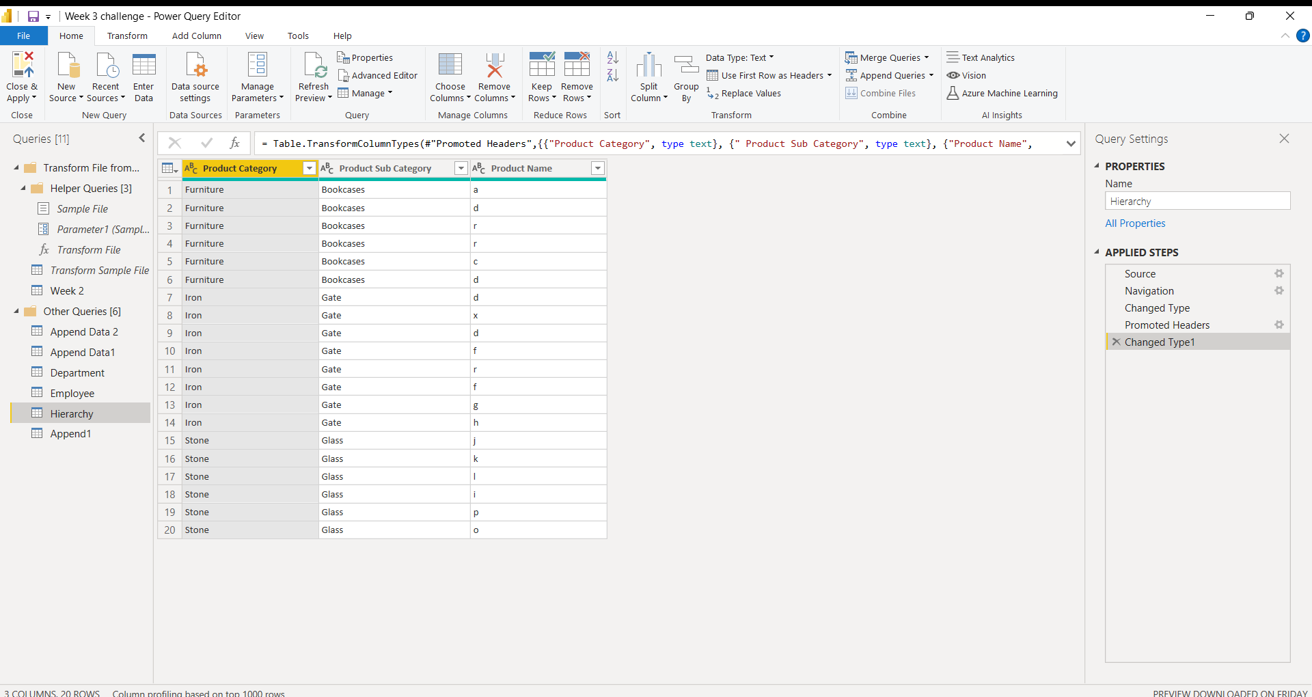

This is a image of hierarchy Product Hierarchy in Power BI Desktop.